**Mohamed Sharbudeen**

Smart Meeting Organizer

# Product Approach

Basic design approach of the application is to make a user book a meeting hall with minimal interaction and intuitive approach. Starting home page is presented with current booking details and available slots. A user who just needs the info about ongoing meets could just make use of. Next page would allow the user to make a booking for himself/ team. This page is presented with only necessary info in order to book the hall. Once the preferred details are given in, available room slots are listed. After confirming the room success page is shown and redirected to the home page.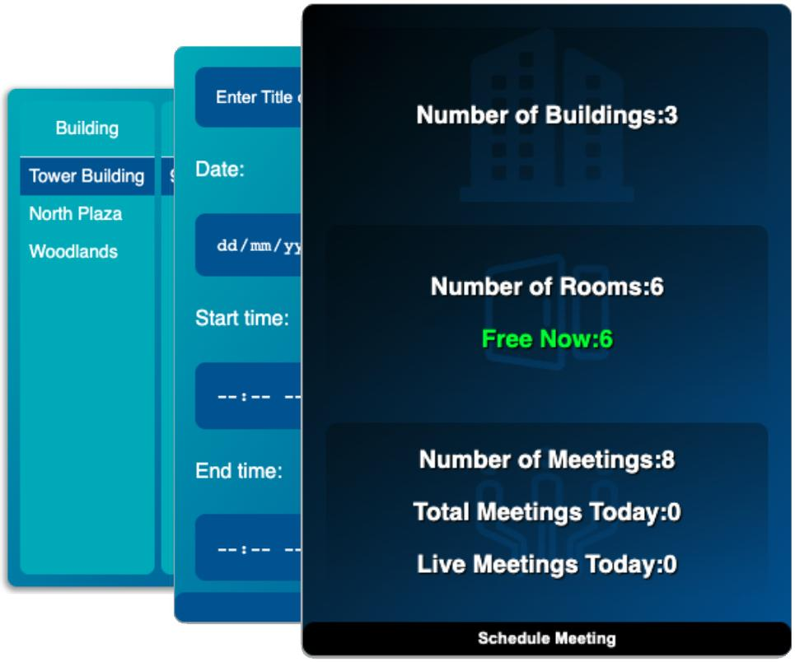

## 

## Intuitive Solution

In order to get the vacancy details, input data from the user needs to be prioritized. Date and time are the primary concerns. List available slots in a side pane component with Buildings, Floors, Rooms with seat count. This will avoid the trial and error from user, and increases the chance of booking a hall

### Key Features

Highly extensible and modular code with capabilities to leverage theme and settings

# Details

**Home Page**

* Total count of buildings shown. Total rooms and currently available rooms are shown. To check vacancy. Total live count of meetings and today’s meet count to assess the traffic.
* This meta info will be useful for planning accordingly.
* Inorder to extract the needed count info. Just iterate the input JSON once and get the metrics (complexity O(inputData))
* Similarly the given input format isn't best for identifying vacancy. An Iteration seems to be needed for checking.Transforming input JSON into MAP like structure. Building -> Floor -> Room for better handling. Server response needs to be changed like that
* Add meeting button to proceed further (1st Click)

**Add Meeting Page**

* Title of Discussion, Start and End times, Date are received as input. Priority data are the timings. We can meet on different floors but not later.
* In order to know the vacant times, it's complex to design a calendar app for now with limited time.
* In next page user can even prioritize building / floor to timing rooms available which user could choose from
* Proceed to check availability (2nd Click)
* Iterate the meetJSON and check if there are rooms with no meets at that given time

**Room Booking Page**

* Available Building , floor ,Room name, seat count are to be shown at the specified time slot are listed. If no rooms, users can be able to navigate to add the meeting itself.
* Once room is clicked, booking is finalized and redirected to success page (3rd Click)

**Success Page**

* Identity of the user to notify them can be taken care of by IAM management.(Data Entry)
* Summary of the booking is shown

# Future Enhancements

1. Based on logged in user’s geography, sort the available slots and prioritize it
2. Show an intuitive calendar component where the user knows what timings are available. Instead of giving timing as priority. User can select building/ Floor as priority and choose available timings
3. I18n language support for International usage
4. For larger data sets of input JSON, load on demand. Load only a 10 days span of data.
5. Limit bookings for past and give a span in future
6. Possibility to edit and cancel a meet
7. Lazy load the JS util modules
8. Tooltips, accessibility options/ UI design for visually impaired.
9. Mobile based responsive design.
10. Automation cases to test UI functionalities.
11. Infinite scrolling functionality
12. Ability to treat the as widget - maximize and minimize

# Manual test cases

* All types of input JSON with buildings, floors and rooms.
* Input validation in Add meeting form page
* Multi threading cases if the JSON is fetched and persisted to a server

# Code Details

*const appProps = {*

*title : WIDGET_TITLE,*

*theme : {*

*type : WIDGET_THEME_TYPE.DARK,*

*size : WIDGET_SIZE.MEDIUM,*

*}*

*}*